Name: Sahaj Pathak (Section ‘D’)

Basic Programming & UML Questions

Question 1: Even or Odd
A program that asks the user to enter a number and checks whether it is even or odd, displaying an appropriate message.
Pseudocode
BEGIN
DISPLAY "Enter a number: "
INPUT number

IF number MOD 2 == 0 THEN
DISPLAY number, " is Even"
ELSE
DISPLAY number, " is Odd"
ENDIF
END
Flowchart
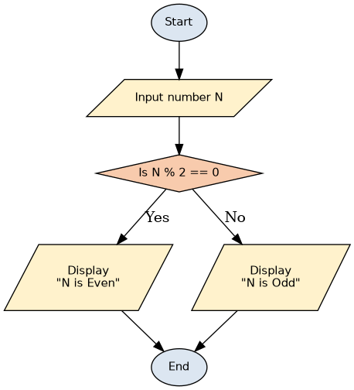
Figure 1.1 — Even/Odd Checker Flowchart

Use Case Diagram
Actor: User
Use Case: Check the Number is Odd or Even.

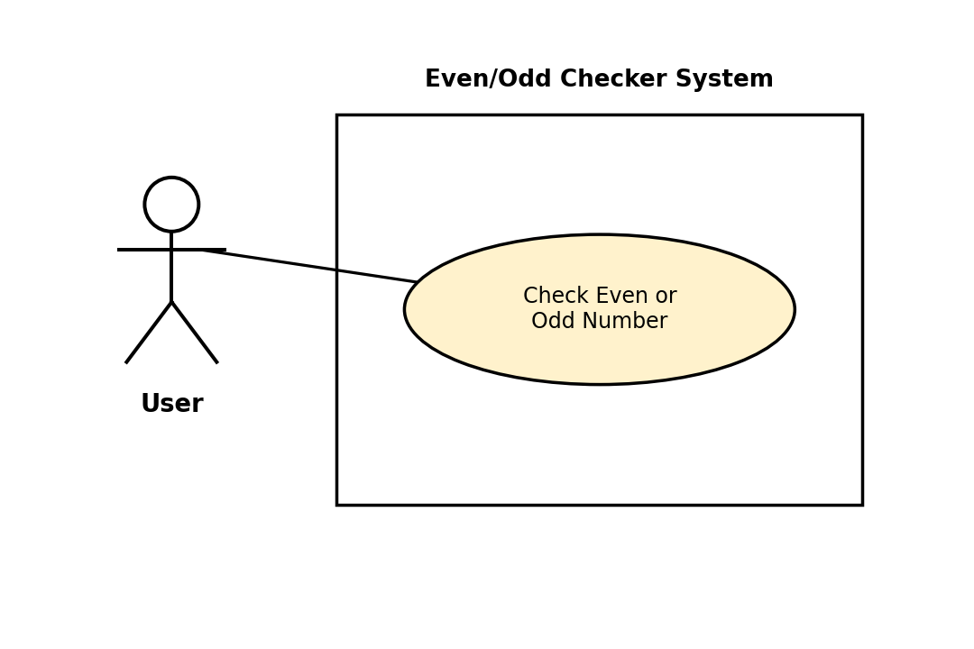
Figure 1.2 — Even/Odd Checker Use Case Diagram

Question 2: ATM System
A simple ATM system starting with an initial balance of Rs. 10,000, offering Check Balance, Deposit Money, Withdraw Money, and Exit. Withdrawal checks that the account has sufficient balance before completing the transaction.
Pseudocode
BEGIN
balance = 10000
choice = 0

WHILE choice != 4
DISPLAY "1. Check Balance"
DISPLAY "2. Deposit Money"
DISPLAY "3. Withdraw Money"
DISPLAY "4. Exit"
INPUT choice

IF choice == 1 THEN
DISPLAY "Your balance is: ", balance

ELSE IF choice == 2 THEN
DISPLAY "Enter amount to deposit: "
INPUT depositAmount
balance = balance + depositAmount
DISPLAY "Deposit successful. New balance: ", balance

ELSE IF choice == 3 THEN
DISPLAY "Enter amount to withdraw: "
INPUT withdrawAmount
IF withdrawAmount <= balance THEN
balance = balance - withdrawAmount
DISPLAY "Withdrawal successful. New balance: ", balance
ELSE
DISPLAY "Insufficient balance!"
ENDIF

ELSE IF choice == 4 THEN
DISPLAY "Thank you for using the ATM. Goodbye!"

ELSE
DISPLAY "Invalid choice. Please try again."
ENDIF
ENDWHILE
END

Flowchart
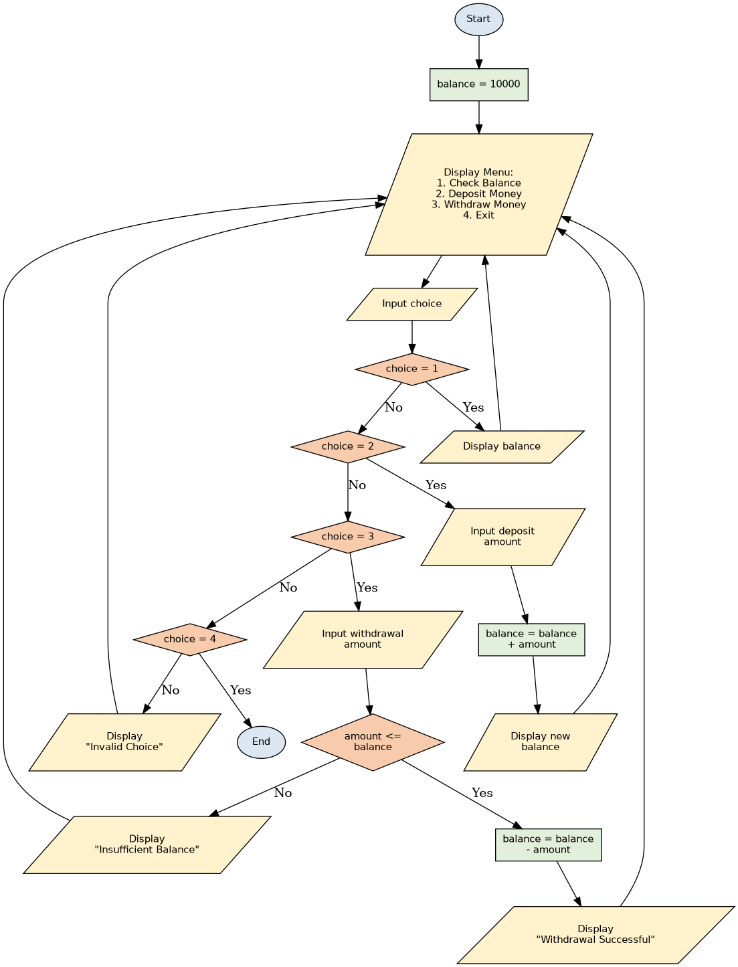
Figure 2.1 — ATM System Flowchart
Use Case Diagram
Actor: Customer.
Use cases: Check Balance, Deposit Money, Withdraw Money, Exit. The Withdraw Money use case has an <<include>> relationship with Check Balance, since the system must always check the current balance as part of processing a withdrawal. The Display Insufficient Balance Alert use case has an <<extend>> relationship with Withdraw Money, since that alert only occurs optionally — when the requested withdrawal amount exceeds the available balance.
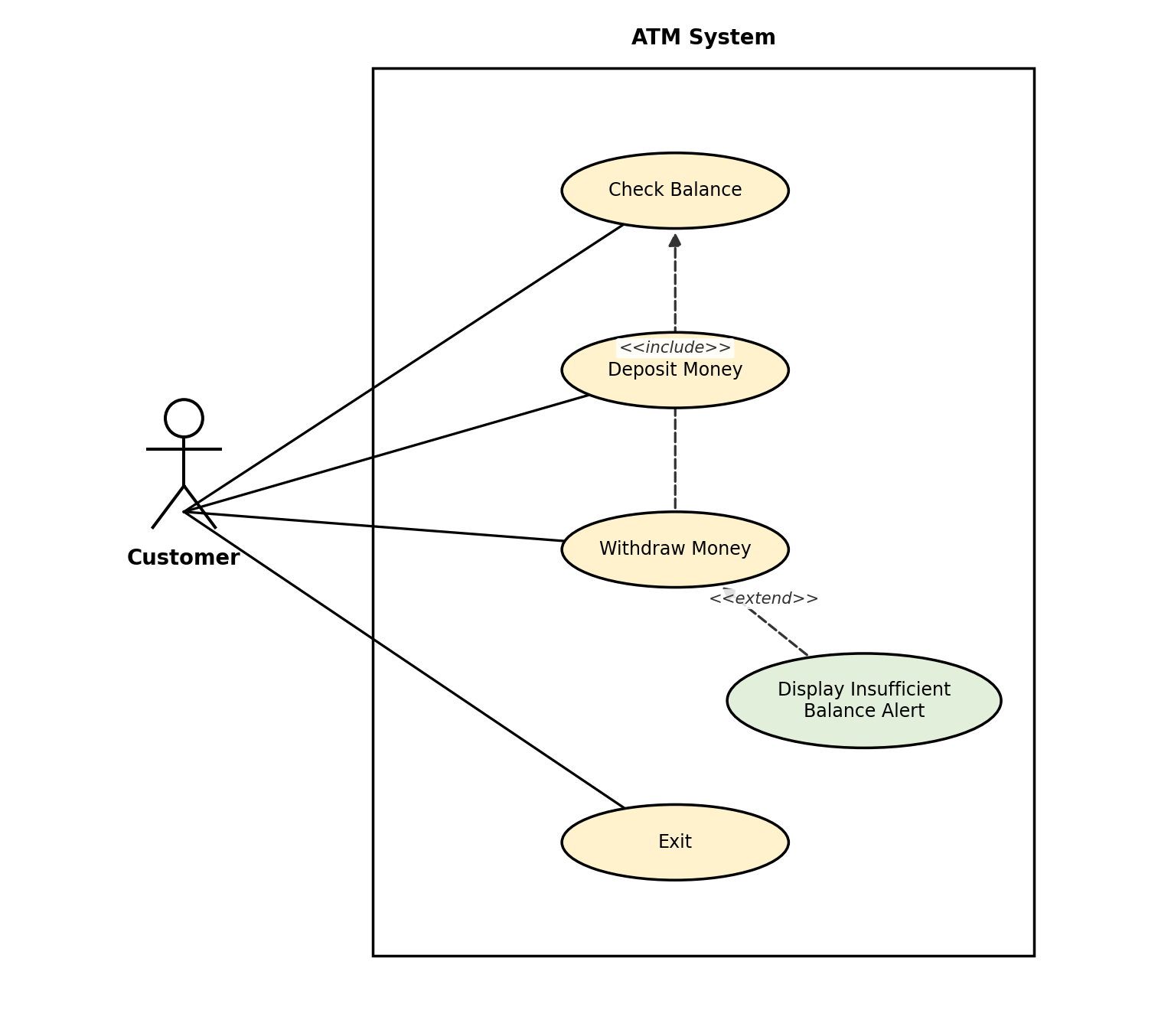
Figure 2.2 — ATM System Use Case Diagram

Question 3: Temperature Checker
A program that asks the user to enter a temperature in Celsius, converts it to Fahrenheit, displays both values, and classifies the temperature as Cold (below 20°C), Normal (20°C to 30°C), or Hot (above 30°C).
Pseudocode
BEGIN
DISPLAY "Enter temperature in Celsius: "
INPUT celsius

fahrenheit = (celsius * 9 / 5) + 32

DISPLAY "Celsius: ", celsius, " C"
DISPLAY "Fahrenheit: ", fahrenheit, " F"

IF celsius < 20 THEN
DISPLAY "Cold"
ELSE IF celsius <= 30 THEN
DISPLAY "Normal"
ELSE
DISPLAY "Hot"
ENDIF
END

Flowchart
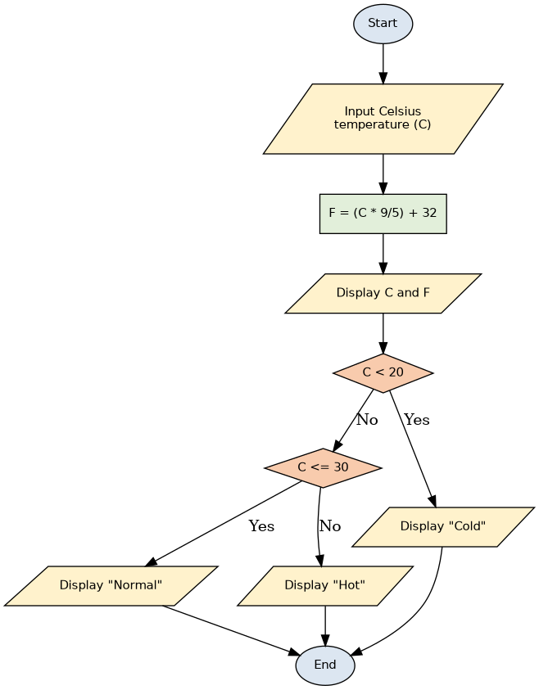
Figure 3.1 — Temperature Checker Flowchart

Use Case Diagram
Actor: User
Use Case: The diagram below models the Temperature Checker program.
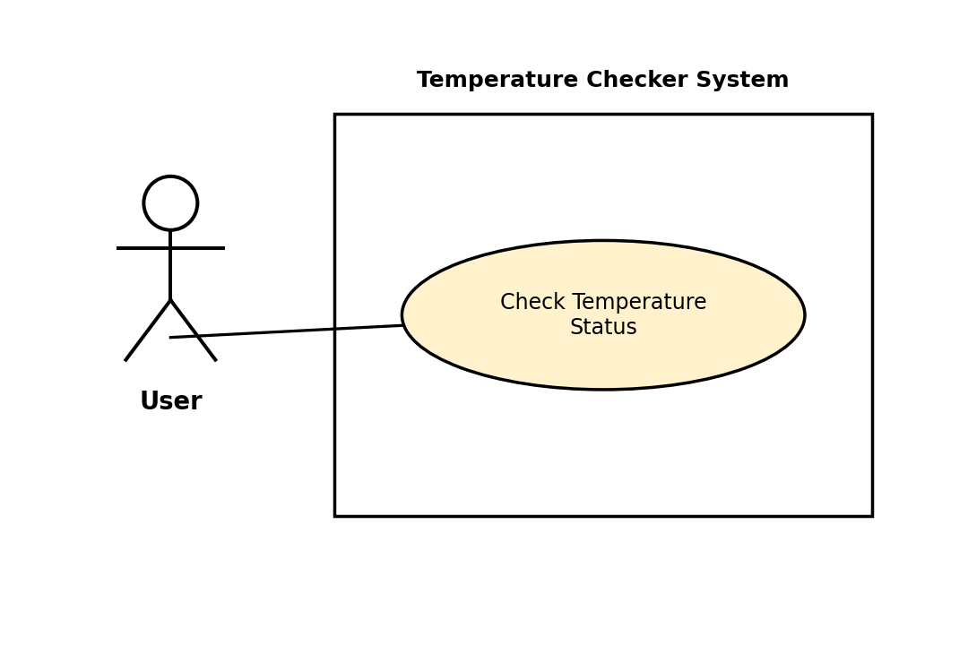
Figure 3.2 — Temperature Checker Use Case Diagram

